

OFFICIAL RULES AND REGULATIONS FOR MUNDIALITO FOOD CITY 2026
With 20 years of tradition in PHX, Arizona, these rules and regulations are mandatory for all teams and participants. The following document outlines the rules, tournament formats, conditions, and sanctions to ensure the fair, organized, and professional development of the tournament.
I. GENERAL PROVISIONS AND PARTICIPATION
1. Matches and Protests
- Match finality:
All matches will be treated as finals. Protests of any kind are not allowed unless supported by proper evidence. Any protest must be accompanied by a fee of $150, which will be refunded if the protest is approved.
2. Player Participation and Eligibility
- Female players:
Girls can play in one age category below their official division. For example, a girl born in 2012 can participate in the 2013 category. Additionally, girls are allowed to play in a category one year above their official division (e.g., a girl born in 2011 may compete in the 2012 category).

- Participation in two teams:
Boys may play for two teams as long as they meet the appropriate age requirements. For instance, a boy born in 2011 may play for teams registered in the 2011 and 2010 categories, provided he is properly registered in both teams.
Players are not allowed to play in two teams within the same category during the same year (NO EXCEPTIONS).
3. Registration and Documentation
- Credentials and roster:
Teams must present their complete roster and player credentials (or IDs) for each match without exception. The team can show the approved a digital roster but the approved stamped picture ust be visible. These should follow the format provided in the official image.
At the end of each match, credentials will be returned. It is the coach's responsibility to confirm the final score with the referee and sign the official scorecard.
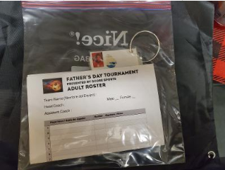

4. Schedule, Results, and Error Corrections
- Match schedules and results can be viewed online at:
https://system.gotsport.com/org_event/events/53917
ABOVE IS THE UPDATED URL
- Important: Any errors observed in match results should be reported immediately to the Tournament Headquarters with Jesse or Jason calling/texting 602-920-0179. Or 602-622-2518
5. Field Placement and Location
- Home and Away Teams:
  - Per the schedule: The "Home" team (listed first in the schedule) and their supporters must position themselves on the West side of the field, while the "Away" team must stay on the East side.
  - Per the field diagram: Home teams should position themselves on the North side of the field, and visiting teams should position themselves on the South side.
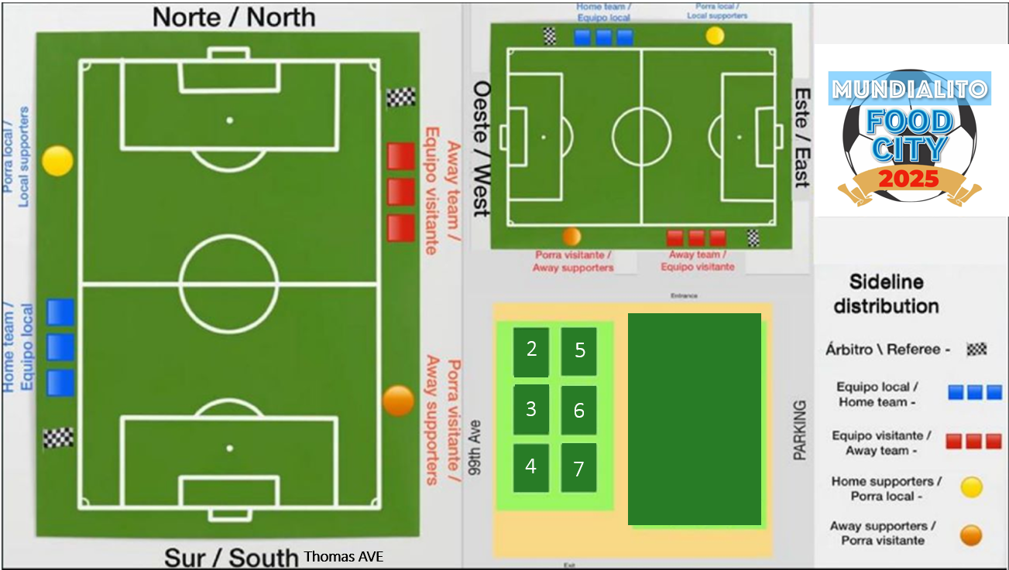
- Matches played at Desert West:
The same positioning applies to Desert West #1, Desert West #2, and the Synthetic field.
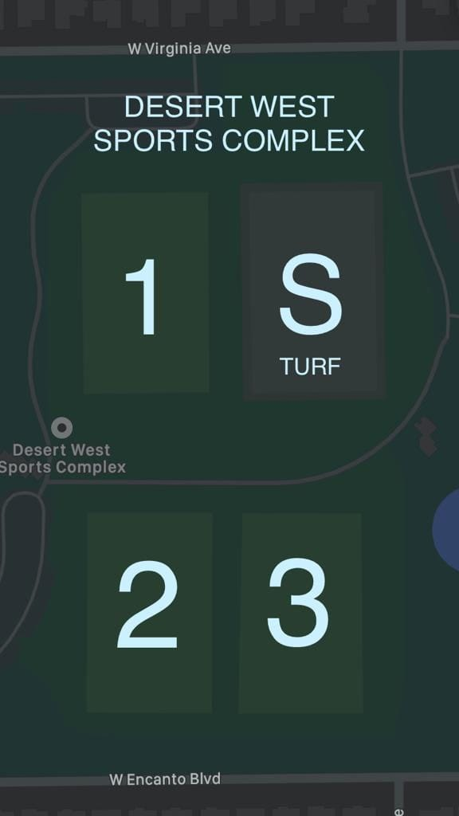

- Locations of fields:
  - West Valley Events Complex is located at 99th Ave and Glendale.
  - Desert West Complex is located on 63Ave and Encanto
Desert West and Synthetic fields are located at 63rd Ave and Encanto. If your match is at the Synthetic field, it is recommended to park near 63rd Ave and Virginia.
The diagram provided for the West Valley Sports Complex outlines the exact locations for each team and their supporters. It is essential to follow this guideline and inform all parents to avoid confusion.
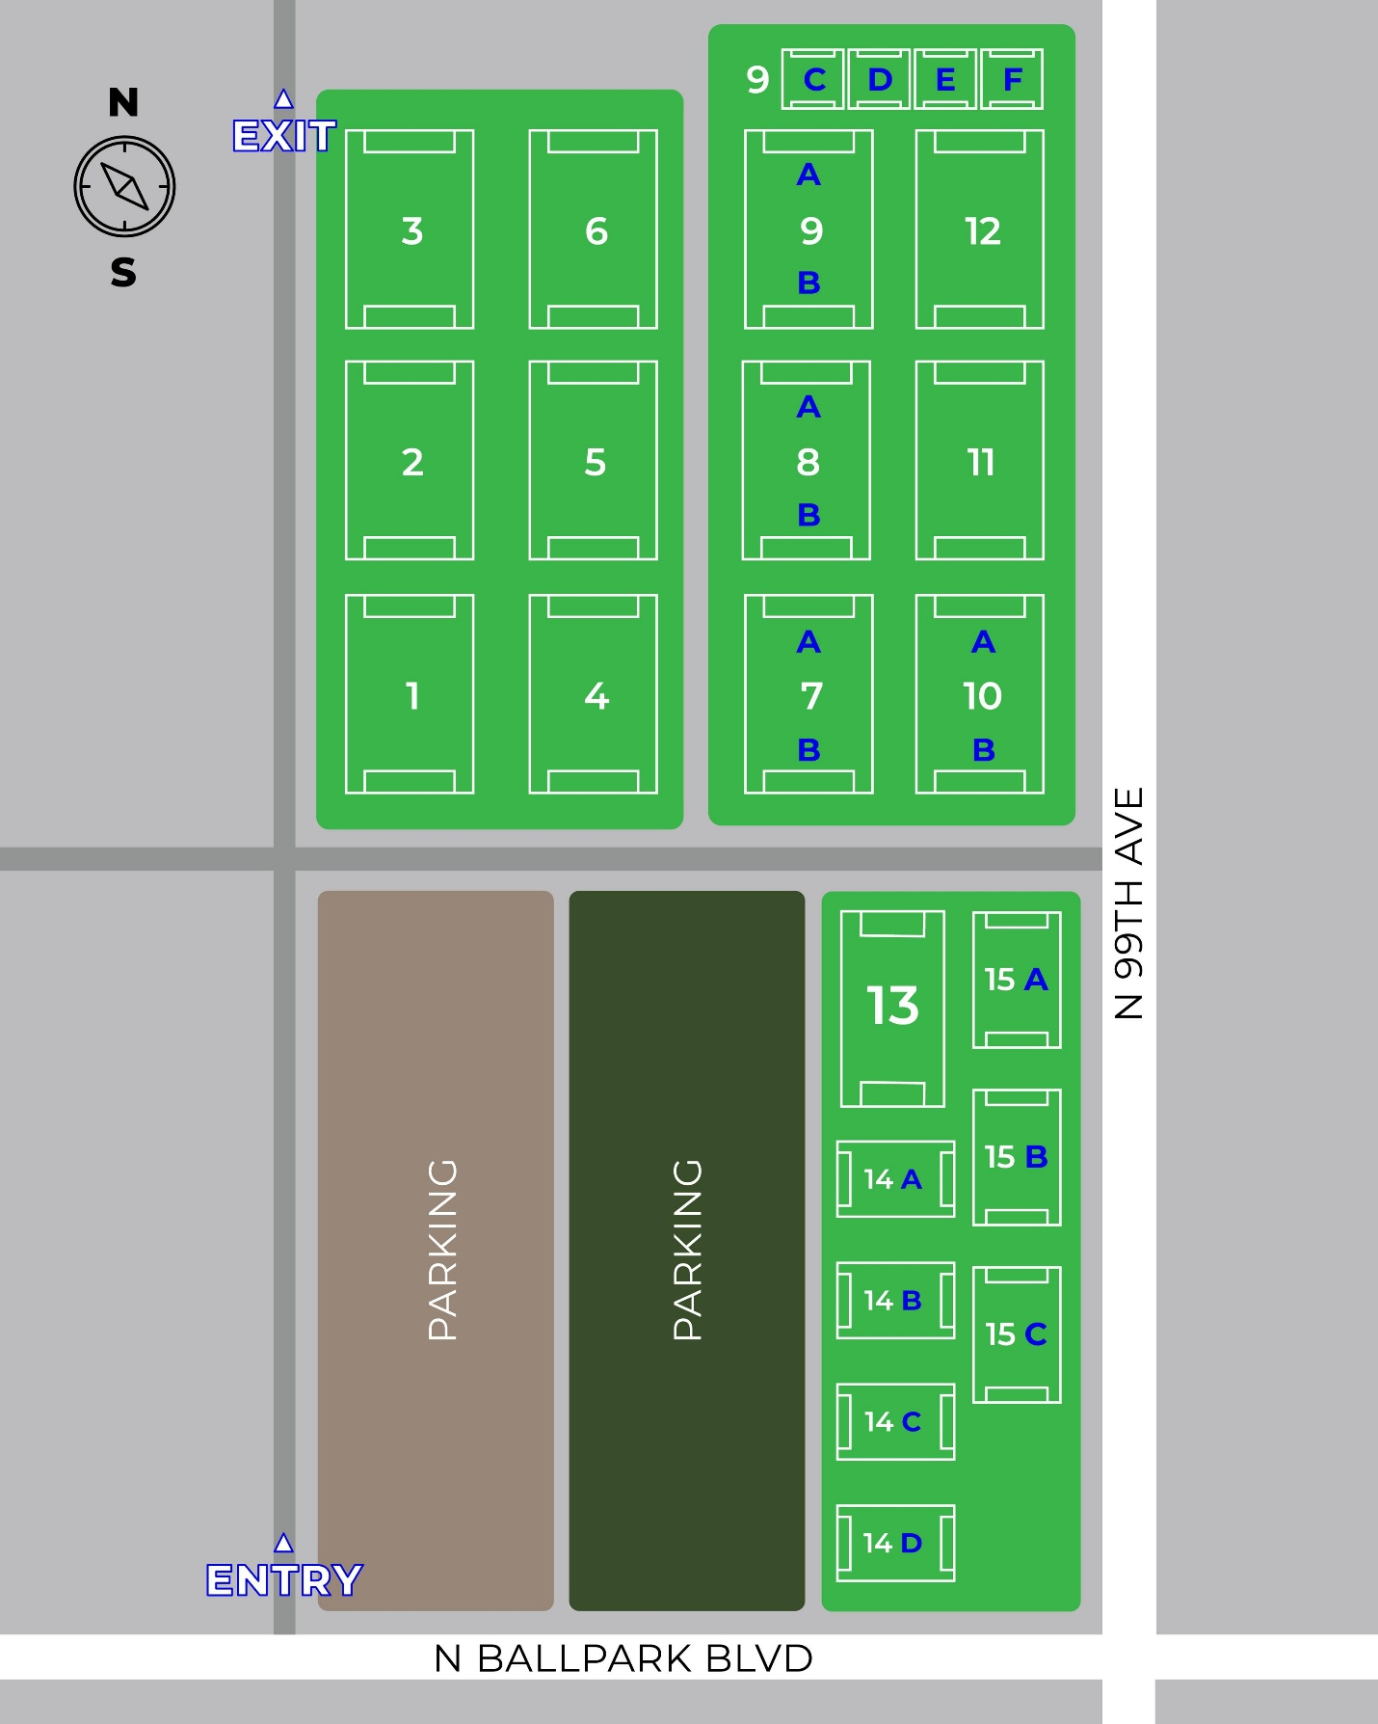

6. Technical Game Rules and Ball Use
Offside and Heading Application:
- Offside is not applied in 4v4 categories (2020–19 and 2018).
- Heading is not allowed in categories 2017, 2016.
- Heading is allowed in categories 2014 and 2015.
(Note: For the next season, the 2015 category will officially permit heading; however, in this tournament, heading is allowed in both 2014 and 2015 categories).
Ball Type and Match Format by Category:
- Categories 2020–2018: Size #3 ball, played in a 4v4 format.
- Categories 2017–2016: Size #4 ball, played in a 7v7 format.
- Categories 2015–2014: Size #4 ball, played in a 9v9 format.
- Categories 2013–2007: Size #5 ball.
- Each team is responsible for providing their own ball.
7. Use of Pinnies for Jersey Color Conflicts
In case of a jersey color conflict, the home team must wear pinnies. These can be collected at the Tournament Director's tent, upon presenting proper identification.

II. GROUP FORMATS, CLASSIFICATION, AND GAME DURATION
1. Group Formats by Category
- Categories 2020
1 Group of 4 Teams for a total of 4 teams. Check Schedules.
- Category 2018 S1
2 groups of 4 teams, for a total of 8 teams. Please check schedules.
Category 2018 A
2 Groups of 4 Teams, for a total of 8 teams. Please check the schedules.
Categories 2017-18B
2 Groups of 4 teams, for a total of 8 teams. Please check the schedules.

- Categories 2017-18A – 2016A -2014- 2013 S1 -2012 A -2010 -
3 groups of 4 teams, for a total of 12 teams. The first-place team in each group, along with the best second-place team (according to the tie-breaker), advances to the semifinals.

- Categories High School Div, 2009, 2012 B – 2013 G – 2016B – 2018A -2018S1 -
2 groups of 4 teams, for a total of 8 teams. The first-place team in each group advances to the final, as indicated in the tournament schedules.

- Categories 2015A – 2019 G
4 groups of 4 teams, for a total of 16 teams. The first-place team in each group advances to the semifinals; the 2 semi final winners progress to the Grand Final.

- Categories 2016B - 2020 A – 2011 G – 2013 S2 – 2016B
2 groups of 3 teams, for a total of 6 teams. The 2 teams with the highest points from both groups (regardless of whether they are from the same group) advance to the Grand Final.
2 groups of 3 teams for a total of 6 teams will play cross Bracket. Bracket “A” will play Teams in Bracket “B” (All 6 teams will be grouped together) and the 2 top teams by point from all 6 teams will play in Final.
Important Note:
In the categories 2020, 2019 & 2018 (4v4), offside does not apply AND THERE ARE NO DIRECT KICKS. ALL RESTARTRS ARE INDIRECT It is imperative to communicate this rule to players and parents to avoid misunderstandings (this rule applies exclusively to these categories).
E. Categories 2013, 2012, 2011, 2010, 2009, and High School Division (11v11)
Elimination Round:
2 halves of 25 minutes each, with a 10-minute break.
Semifinals and Finals:
2 halves of 30 minutes each, with a 10-minute break.

B. Categories 2014 /2015 A/B (9v9)
Elimination Round:
3 elimination matches: 2 halves of 25 minutes each, with a 10-minute break.
Semifinals and Finals:
2 halves of 30 minutes each, with a 10-minute break.
A. Categories 2016A – 2016B – 2017-18A -2017-18B (7v7)
Elimination Round:
3 elimination matches: 2 halves of 25 minutes each, with a 10-minute break.
Semifinals and Finals:
2 halves of 25 minutes each, with a 10-minute break.
C. Categories 2020-2019 -2018 (4v4)
Regular Matches:
2 halves of 20 minutes each, with a 10-minute break.
Semifinals and Finals:
2 halves of 20 minutes each, with a 10-minute break.
Tie-breakers in Semifinals and Finals:
4 penalty kicks without a goalkeeper, taken from midfield.
If the tie persists, substitutes will take penalty kicks. Once all players have participated in the penalty sequence, the first kicker resumes the sequence alternately until a winner is determined.(Remember only for the above age groups) 4 vs 4

4. Scoring System: 10-Point Rule
Match Results:
- WIN: 6 points.
- DRAW: 3 points.
- LOSS: 0 points.
Goal Bonus:
1 point per goal scored, up to a maximum of 3 points.
Shutout Bonus:
1 extra point if the opposing team finishes the match without scoring.
(This rule does not apply to matches that end in a 0–0 draw; no extra points will be awarded for a shutout in this case).
Scoring Examples:
- If the team wins 3–0: 6 (for the win) + 3 (for the maximum 3 goals scored) + 1 (for keeping the opponent at zero) = 10 points.
- f the match ends in a 0–0 draw: 3 points.
- If the match ends in a 2–2 draw: 3 (for the draw) + 2 (for 2 goals scored) = 5 points.

Youth Divisions:
(For categories: 2020-2019-2018-2017-2016, 2015, 2014, 2013, 2012, 2011, 2010, 2009, High School Division)
- Champion:
  - Trophy and medals.
  - FINALIST
- Trophy and medals for the champion and runner-up teams in all divisions.

2. Group Winners and Tie-Breakers (for classification)
The team with the most points at the end of the elimination round will be declared the group winner.
In the event of a tie, the winner will be determined as follows:
- Head to Head: The winner of the match between the two tied teams in group play.
- Goal Differential: Total Goals for minus total goals allowed.
- Goals Against:
- Goals Scored:
- Most Wins: Team with the most wins during the Group Phase.
- Penalty Shootout: A series of 5 penalty kicks will be taken alternately between teams.

In the event that 3 teams are tied on the all criterias the tie-breaker will proceed as follows:

Example: If three teams advance ( first place from Group A, second from place B and third place from group C) the team from Group A will directly advance to the penalty round specified in point (6) while the remaining two teams will compete in a penalty shootout. The winner of this penalty shootout will then face the Group A team in Penalties, repeating the process until a final winner is determined

IV. DISCIPLINE, SANCTIONS, AND ADDITIONAL RULES
1. Red Cards
- A player who receives a red card will automatically be suspended for the next match.
- The number of matches suspended will depend on the severity of the offense.
- At the end of the suspension, the player's credential or ID will be returned to them or to their coach. It must be collected from the refereeing coordinator (Fernando Mora).
2. Registrations
- If a team is found attempting to register or using a player who has not been properly registered, the team will be disqualified from the tournament.
3. Teams That Fail to Show Up for Matches
- Teams that do not show up for their match will be disqualified from the tournament.
- Additionally, they will be banned from participating in future tournaments organized by Food City, and the league they belong to will be sanctioned.
- Please ensure that others are not affected by this.
4. Aggression
- Any player or team member who physically attacks a referee, a member of the organizing committee, or a tournament official will be suspended and permanently banned.
- Relevant documentation will be handed over to law enforcement authorities for immediate arrest.
- Maintaining respect and controlling this type of behavior is crucial.

5. Matches Without an Opposing Team
- If the opposing team fails to show up, the present team will be declared the winner with a score of 2–0, earning a total of 9 points.

6. Mandatory Use of Shin Guards
- Shin guards are mandatory for all matches (NO EXCEPTIONS).
7. Substitutions and Changes
- There is no limit on the number of substitutions.
- Changes are made at the discretion of the referee, provided they have authorization from the central referee.
8. Punctuality: "NO TOLERANCE TIME"
- All matches must begin at the scheduled time.
- No match will be allowed to start late.
9. Heading Restrictions
- Categories where heading is not allowed:
2020-2019–2018-2017-2016
- Only youth categories from 2014–2015 & 2013 up to 2008-07 may utilize heading.
10. Supporters (Porras)
- Coaches are responsible for the behavior of their supporters and the actions of substitute players.
- It is essential to help manage their behavior and explain the tournament rules, as failure to do so will leave the tournament organizers with no other alternatives.

11. Players Registered in Two Teams in the same Division
- A player becomes officially tied to the first team they present themselves with, even if they do not actively play; simply being on the bench establishes their link to the team.
- If the player then participates with another team after their initial match, both the player and the second team will be disqualified (NO EXCEPTIONS).
- The coach is responsible for ensuring the player has not presented themselves with any other team.
- Remember a player can play with 2 teams but diferent Age Group. For example a player can play with a 2016 team and also a 2015 but not in the same age group.
12. Punctuality and Exceptions for Starting Matches
- General rule:
No tolerance time is permitted for matches to begin; all matches must start strictly at the time scheduled (NO EXCEPTIONS).

13. Disclosure of Responsibility
- Liability Waiver:
Mundialito Food City 2026 is not responsible for injuries or any type of damage suffered during the tournament. Furthermore, the tournament organization disclaims any liability toward participants, sponsors, officials, or staff members.
- Participation at Your Own Risk:
Participation in Mundialito Food City 2026 is carried out entirely at the player's, coach's, or team's own risk.
- Visual Media Usage:
Mundialito Food City 2026 reserves the right to use photographs taken during the tournament for social media and promotional purposes.
- Tournament Suspension or game suspension due to weather or outside conditions Copa Officials and Referees have the right to suspend or terminate or stop a match if weather conditions or security are not optimal to continue the match. If conditions or situations improve, the game may be resumed or rescheduled. If the game has been played for more than 75% it will be declared final at the time of the stoppage.
- If teams are in the elimination phase a penalthy shootout will take place.
- We will make every effort to reschedule and play matches but cannot offer monetary compensation due to expenses incurred by the tournament.
V. FINAL MESSAGE
On behalf of the entire Mundialito Food City 2026 organizing team, we sincerely thank you for your participation and commitment to this tournament. Your enthusiasm, dedication, and passion for the sport are the driving force behind this event, which year after year brings together exceptional talent and energetic, sports-loving communities.
We also extend our gratitude to coaches, families, and fans whose support helps make every game a memorable experience. We invite you to celebrate every match with sportsmanship, respect, and joy, reinforcing the values this tournament promotes.
May this Mundialito be a celebration of football, friendship, and collective effort!
We are honored to have you here. Best of luck to all the teams, and may the best one win!

